Thank you for showing interest in the 75th Annual Gregg County Fair and Exposition. Fair dates are September 6th thru 14th, 2024.
All information you need is included on the following contract. Please be sure you read and can comply with the contract you are signing.
Please review the contract for dates, prices, times, etc.
If you fail to comply with one or any of the stipulations your contract will be void.
We look forward to your participation in what we feel is one of the most reasonably priced opportunities you have to display your products.
For more information, please call (903) 753-4478, fax (903) 753-5452 or visit our website at www.GreggCountyFair.com.
Contracts and deposits are due back as stated on the contract. There are no exceptions!!! Spaces will be released.
Again, thank you for your interest, and please call if you have any questions.
Sincerely,
Billy G. Clay
GENERAL MANAGER

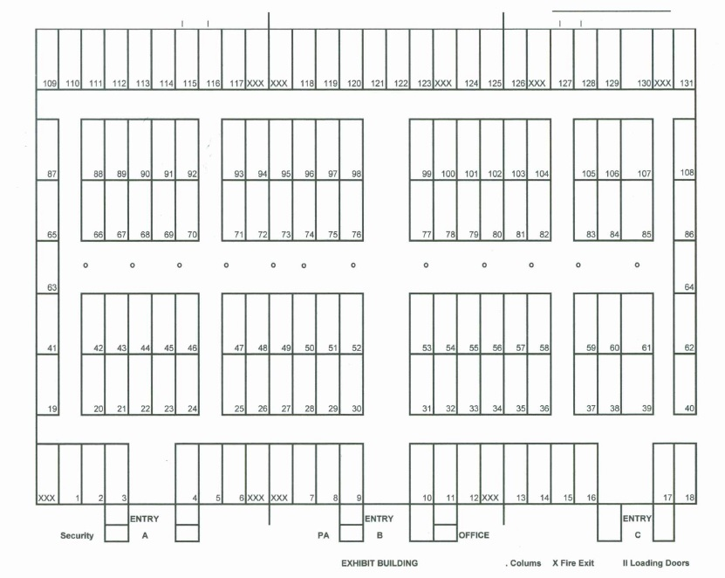
AGREEMENT OF LEASE FOR INSIDE EXHIBITOR
By reading and signing this contract, you acknowledge you understand and will follow ALL guidelines listed.
- The Lessor for this contract is the Gregg County Fair and Exposition.
- The Lessor agrees to pay all utilities and provide electricity within reasonable distance of said booth.
- The Lessor will furnish one (1) non skirted table per paid contract. Chairs not provided.
- The Lessor will supply 4 exhibitor passes per paid contract.
- Leased space will be one (1) 10 X 10 space, or may lease more.
- The Lessee agrees to have at least one person in their space from opening to closing each and every night.
- The Lessee agrees not to staple, pin or tape anything to drapes. Also drapes will not be used as a table cloth.
- The Lessee agrees to have display set up by 6:00 p.m. Thursday, September 5th. This does not have to be complete for items such as jewelry, glass, etc., but table and decorations or banners must be in place.
The Lessee will pay 75% of rent upon signing this contract. BALANCE DUE APRIL 1st. NO REFUNDS AFTER APRIL 1.
Gregg County Fair will NOT be responsible for your booth while occupied or unoccupied.
If this is a corporate paid space, return signed contract within 10 days stating that the check is in the mail.
Give a full list of all items that will be shown or sold in your booth. There are no exclusives on any products.
DUE TO SECURITY, NO GUNS OR KNIVES WILL BE SOLD TO ANYONE UNDER 18. THIS INCLUDES REAL OR FAKE.
This Contract must be signed and postmarked with the deposit 10 days from the contract date or this contract will be void. No exceptions! This contract is non-transferable!!!!!
RV SPACES - $180.00, WATER & ELECTRICITY INCLUDED FOR THE ENTIRE FAIR. CAN BE PAID WITH CONTRACT.
NO CHAIRS PROVIDED!!!!!!!!!
Rent is as follows:
- Corner Space $275.00
- Inside Space $250.00 Non-profit $50.00 per space
NO Refund will be made for cancellations after April 1st.

Important Dates

Important Date
MOVE IN Wednesday September 4 10:00 A.M. - 8:00 P.M.
MOVE IN Thursday September 5 10:00 A.M. - 8:00 P.M.
INSPECTION Thursday September 5 10:00 A.M.
INSPECTION Friday September 6 10:00 A.M.
HOURS OF OPERATION Friday September 6 6:00 P.M. - 12:00 A.M.
HOURS OF OPERATION Saturday September 7 4:00 P.M. - 12:00 A.M.
HOURS OF OPERATION Sunday September 8 4:00 P.M. - 10:00 P.M.
HOURS OF OPERATION Monday September 9 6:00 P.M. - 10:00 P.M.
Tuesday September 10 6:00 P.M. - 10:00 P.M.
Wednesday September 11 6:00 P.M. - 10:00 P.M.
Thursday September 12 6:00 P.M. - 11:00 P.M.
Friday September 13 6:00 P.M. - 12:00 A.M.
Saturday September 14 4:00 P.M. - 12:00 A.M.
MOVE OUT Sunday September 15 10:00 A.M. - 6:00 P.M.
MOVE OUT Monday September 16 10:00 A.M. - 6:00 P.M.

NAME: _____________________________  ADDRESS: __________________________  CITY: _______________________________  STATE: ______________________________  ZIP: _________________________________  Company Phone:______________________  Vendor Signature: _____________________ | OFFICE USE ONLY  Amount Due: $________  RV Due: $_________  Amount Paid : $__________  Balance Due: $__________  Billy G. Clay, General Manager  Lessor – Gregg County Fair
*************** EMAIL: CLAY812@AOL.COM OR FAX 903-753-5452******************
ACTIVE TEXAS Sales Tax Number __________________________________________
Contact name: _______________________
Payment Methods:____________________
Cash, Check, Money Order or PayPal – greggcountyfair.com – vendor tab
Cell (or alternate number): _________________________

Email address: ________________________________
Date of contract: _____________________
Space assigned: ___________________________________
COMPLETE DESCRIPTION OF ALL ITEMS SOLD IN THE SPACE: NO EXCLUSIVES

___________________________________________________________________________________________________________________________________________________________

NAME: ______________________________  ADDRESS: ____________________________  CITY: ________________________________  STATE: ______________________________  ZIP: _________________________________  Company Phone: ______________________  Vendor Signature:_____________________ | OFFICE USE ONLY  Amount Due: $_________  RV Due: $_________  Amount Paid: $__________  Balance Due: $__________  Billy G. Clay, General Manager  Lessor – Gregg County Fair
********************COMPLETE, SIGN and RETURN THIS PAGE ONLY
EMAIL: CLAY812@AOL.COM OR FAX 903-753-5452******************
ACTIVE TEXAS Sales Tax Number ______________________________ ***REQUIRED ON CONTRACT
Contact name: ___________________________________
Payment Methods:____________________________
Cash, Check, Money Order or PayPal – greggcountyfair.com – vendor tab
Cell (or alternate number): _________________________

Email address: ___________________________________
Date of contract: _____________________
Space assigned: ___________________________________
COMPLETE DESCRIPTION OF ALL ITEMS SOLD IN THE SPACE: NO EXCLUSIVES

_______________________________________________________________________________________________________________________________________________________________________________________________________________________________________________________________

