Thank you for showing interest in the 69th Annual Gregg County Fair and Exposition. Fair dates are September 7th thru 15th, 2018.
All information you need is included on the following contract. Please be sure you read and can comply with the contract you are signing.
Please review the contract for dates, prices, times, etc.
If you fail to comply with one or any of the stipulations your contract will be void.
We look forward to your participation in what we feel is one of the most reasonably priced opportunities you have to display your products.
For additional information, please call (903) 753-4478, fax (903) 753-5452 or visit our website at www.GreggCountyFair.com.
Contracts and deposits are due back as stated on the contract. There are no exceptions!!! Spaces will be released.
Again, thank you for your interest, and please call if you have any questions.
Sincerely,
Billy G. Clay
FAIR MANAGER
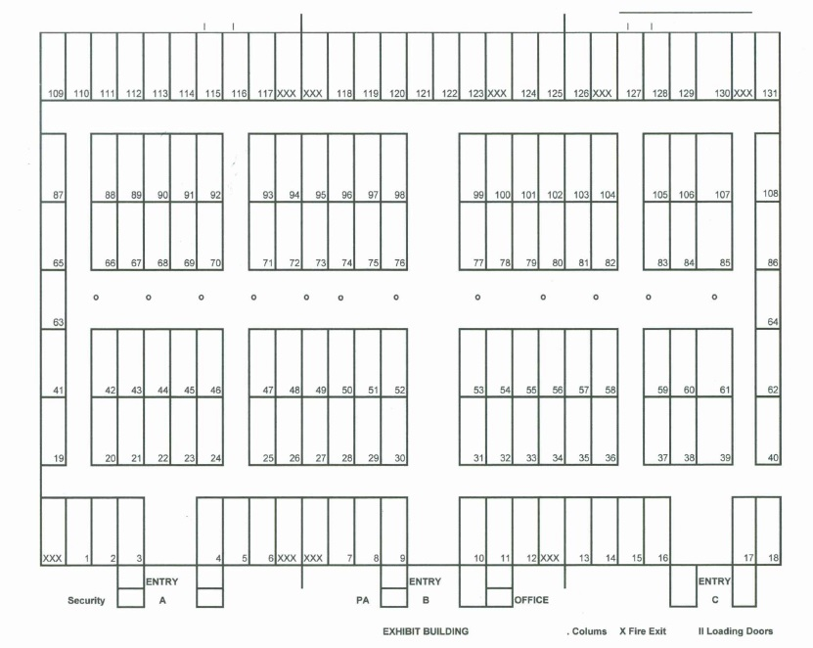
AGREEMENT OF LEASE FOR INSIDE EXHIBITOR
By reading and signing this contract, you acknowledge you understand and will follow ALL guidelines listed.
- The Lessor for this contract is the Gregg County Fair and Exposition.
- The Lessor agrees to pay all utilities and provide electricity within reasonable distance of said booth.
- The Lessor will furnish one (1) non skirted table per contract, NO CHAIRS!
- The Lessor will supply 4 exhibitor passes per paid contract.
- Leased space will be one (1) 10 X 10 space, or may lease more.
- The Lessee agrees to have at least one person in their space from opening to closing each and every night.
- The Lessee agrees not to staple, pin or tape anything to drapes. Also drapes will not be used as a table cloth.
- The Lessee agrees to have display set up by 6:00 p.m. Thursday, September 6th. This does not have to be complete for items such as jewelry, glass, etc. but table and decorations or banners must be in place.
The Lessee will pay 75% of rent upon signing this contract. Balance needs to be paid prior to April 1st.
Gregg County Fair will NOT be responsible for your booth while occupied or unoccupied.
If this is a corporate paid space, return signed contract within 10 days stating that the check is in the mail.
Give a full list of all items that will be shown or sold in your booth. There are no exclusives on any products.
DUE TO SECURITY, NO GUNS OR KNIVES WILL BE SOLD TO ANYONE UNDER 18. THIS INCLUDES REAL OR FAKE.
______________________________________________________________________________
This Contract must be signed and postmarked with the deposit 10 days from the contract date or this contract will be void. No exceptions! This contract is non-transferable!!!!!
RV SPACES - $180.00, WATER & ELECTRICITY INCLUDED
Rent is as follows:
- Corner Space $275.00
- Inside Space $250.00 Non-profit $50.00 per space
NO Refund will be made for cancellations after April 1st.

Important Dates

MOVE IN Wednesday September 5 10:00 A.M. - 10:00 P.M.
MOVE IN Thursday September 6 10:00 A.M. - 10:00 P.M.
HOURS OF OPERATION Friday September 7 6:00 P.M. - 12:00 A.M.
Saturday September 8 4:00 P.M. - 12:00 A.M.
Sunday September 9 3:00 P.M. - 11:00 P.M.
Monday September 10 6:00 P.M. - 10:00 P.M.
Tuesday September 11 6:00 P.M. - 10:00 P.M.
Wednesday September 12 6:00 P.M. - 10:00 P.M.
Thursday September 13 6:00 P.M. - 11:00 P.M.
Friday September 14 6:00 P.M. - 12:00 A.M.
Saturday September 15 4:00 P.M. - 12:00 A.M.
MOVE OUT Sunday September 16 8:00 A.M. - 5:00 P.M.
MOVE OUT Monday September 17 8:00 A.M. - 5:00 P.M.

NAME:  ADDRESS:  CITY:  STATE:  ZIP:  Company Phone:  Lessee***:____________________________ | OFFICE USE ONLY  Amount Due: $  Amount Paid: $_________  RV Due: $__________  Balance Due: $__________  Billy G. Clay, Lessor – Gregg County Fair

ACTIVE TEXAS Sales Tax Number ***REQUIRED ON RETURNED CONTRACT
Contact name: Payment Methods:
Cell or alternate number: Cash, Check, Money Order, PayPal
Email address: ___________________ (greggcountyfair.com/vendor)
Date of contract: _____________________
Space assigned:

NAME:  ADDRESS:  CITY:  STATE:  ZIP:  Company Phone:  Lessee***:____________________________ | OFFICE USE ONLY  Amount Due: $  Amount Paid: $_________  RV Due: $__________  Balance Due: $__________  Billy G. Clay, Lessor – Gregg County Fair

ACTIVE TEXAS Sales Tax Number ***REQUIRED ON RETURNED CONTRACT
Contact name: Payment Methods:
Cell or alternate number: Cash, Check, Money Order, PayPal
Email address: ___________________ (greggcountyfair.com/vendor)
Date of contract: _____________________
Space assigned:

